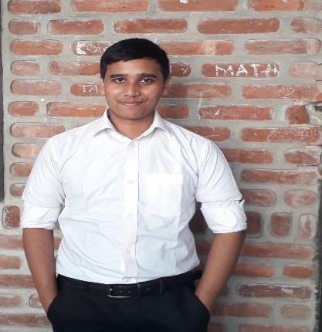Albab Hussain

Tilagor, Sylhet, 01754960315

albabhussainalbab40@gmail. Com

Linked In :Albab Hussain Albab

# Skills Summary

Fluent in Bangali and English speaking

Experts in MS word, MS Excell and MS power point

Expert in programming Language C,C++,Fortran and Math lab

## Undergraduate student of Shahjalal University of science and Technology

I have completed my HSC From Sylhet government College under Sylhet Board in 2020

### Programme Devoloper,08.12.2024

I'm really a capable person to continue my job as a programme devoloper

# I Get the Genius scholarship From CZM in 2021.

## I have been working as a Vice President of SUST shahitto sanshad and communication secretary at SUST school of debate ,Executive Member of SUST MUNA.